Feta in Herby Oil

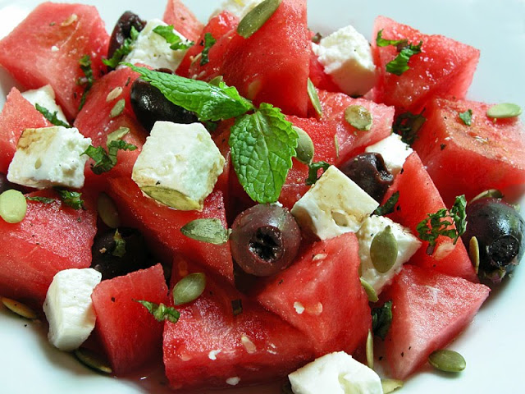
INGREDIENTS
2 tbs chopped parsley
2 tsp chopped thyme
450 ml best green virgin olive oil
575 g British Feta Cheese
6 green olives
6 sprigs each of: thyme, marjoram and rosemary
8 black peppercorns
Few pieces of tinned pimento
METHOD
Grind the parley and thyme into a paste with a little oil with pestle and mortar.
Add the rest of the oil and store in an airtight jar at room temperature for 2 weeks, shaking daily Then cut the Feta cheese into small squares. Line a sterilised open necked jar with herbs, olives etc.
Put in the Feta pieces and cover with well strained olive oil. Leave 2 weeks and serve with drinks or on top of salads.

